**Robo-Phantoms Meeting Minutes**

**Date**: November 11, 2023.

**Time**: 3:30 PM - 6:30 PM.

**Type of Meeting**: In person

**Meeting Facilitator**: Mr. Srinath Madasu. (Coach 1)

**Attendees**:

1. Ajay Muthukumar.
2. Dhruv Shah.
3. Kavin Shankaran.
4. Kayan Patel.
5. Srilakshminath Madasu.
6. Subha Annamalai. (Coach 2)

**Agenda**:

Prototyping,Auton Number 1, Finish taping / truss of field

**Discussions and Decisions**:

1. The team decided to start prototyping the claw we printed two arms of the claw and used a goBilda servo block to attach them
2. We decided on the simplest auton code to start with
3. We discussed the different ways to fix the claws grabbing ability

**Decision(s):** Team members

We decided to start on a simple auton code to drive and park

Secondly, We built a claw to start testing out our different ideas (We added clay and electrical tape to make the claw more compliant)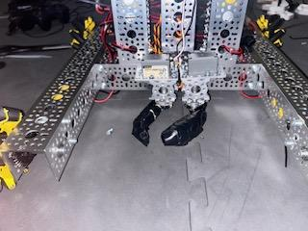.

**7. Tasks for the Upcoming Week(s):**

1. Print Out hex shaft for surgical tubing intake

**8. Announcements:**

The coach announced the scrimmage , First competition date

**9. Open Issues:**

* The arm stopped working
* Our cycle times are extremely slow
* The claw cant score on the back drop
* **Action Items:**
* Finish cutting poly carb , Add team name/number , print alliance markers and start finish prototyping surgical tubing , compliant wheels

**11. Next Meeting Date:**

The next meeting will be held online on November 18, 2023 at 5:00 PM.

**Minutes Prepared By:**

Srilakshminath Madasu